

A newspaper delivery system

# -Project description:

The newspaper delivery system project aims to address the challenges faced by newspaper delivery services in efficiently and effectively managing their operations. The proposed system seeks to automate the entire delivery process, from receiving customer orders to dispatching delivery agents and tracking deliveries.

The system will have several features to enhance functionality, including a user-friendly interface that allows customers to easily place orders and select delivery preferences. Delivery agents will have access to a real-time dashboard that displays delivery routes and updates on pending deliveries. The system will also have an integrated payment gateway to facilitate secure and efficient payment processing.

The project's boundaries will be limited to the newspaper delivery process, with a focus on optimizing the process for both customers and delivery agents. The system will be constrained by factors such as budget, technology limitations, and scalability requirements.

Overall, the newspaper delivery system project aims to revolutionize the traditional newspaper delivery process by introducing a modern, efficient, and customer-centric approach.

## List of team members:

|  |  |
| --- | --- |
| Amr Khaled Gaber Abdelbaset (project Manager) | 21100834 |
| Ahmed Mohamed Elmohamady | 21100821 |
| Ahmed Mohamed Dawood | 21100820 |
| Mohamed Talat Elslmawy | 21100809 |
| Mohamed Ahmed Saad Ali | 21100871 |

**-List the initial identified customer requirements:**

1-Daily delivery lists for each delivery person.

2-A summary of publications delivered to each customer.

1. Automatic bill computation for each customer at the end of each month.
2. Management of customer information, including name, address, phone number, email, delivery preferences, and billing information.
3. Management of publication information, including a list of available publications, their names, prices, and delivery schedules.
4. Management of deliveries, including tracking of delivery personnel, publications assigned to each delivery person, and delivery schedules for each publication.
5. Ability to handle temporary suspension of service for customers who are away on vacation or business trips.
6. Simple and user-friendly interface for newsagents to manage customer information, publication lists, delivery schedules, and billing information.
7. Generation of various reports, such as daily delivery lists for each delivery person, summaries of publications delivered to each customer, and monthly revenue reports.

**-Partition of Identified Customer Requirements:**

## Delivery Management

* + Daily delivery lists for each delivery person.
  + Summary of publications delivered to each customer.
  + Delivery management, including tracking of delivery personnel, publications assigned to each delivery person, and delivery schedules for each publication.

## Billing Management

* + Automatic bill computation for each customer at the end of each month.
  + Management of customer information, including name, address, phone number, email, delivery preferences, and billing information.
  + Management of publication information, including a list of available publications, their names, prices, and delivery schedules.

## User Interface

* + Simple and user-friendly interface for newsagents to manage customer information, publication lists, delivery schedules, and billing information

## Reporting

* + Generation of various reports, such as daily delivery lists for each delivery person, summaries of publications delivered to each customer, and monthly revenue reports.

**The following subsystems and their functions :**

* + **Customer Management System:** This subsystem will be responsible for

storing and managing customer information such as name, address, contact details, delivery schedule, and billing details. It will allow for easy addition, modification, and deletion of customer information.

* + **Publication Mangement System:** This subsystem will be responsible for

managing the list of publications to be delivered to each customer. It will ensure that the correct publications are delivered to each address and will generate a daily publication summary for the newsagent.

* + **Delivery Schedule System:** This subsystem will generate a daily delivery schedule for each delivery person, listing the publications to be delivered to each address.
  + **Billing System**: This subsystem will automatically compute monthly bills for each customer based on their delivery schedule and the publications delivered.

**The traceability matrix between the requirements and identified subsystems is as follows:**

|  |  |  |  |  |
| --- | --- | --- | --- | --- |
| **Requirement** | **Customer Management**  **System** | **Publication Management**  **System** | **Delivery Schedule**  **System** | **Billing System** |
| For each delivery person, the system must print, each day, the publications  to be delivered to each address. |  | Yes | Yes |  |
| The system should also print, for the newsagent, a summary of who  received what publications each day. |  | Yes |  |  |
| Once a month, bills are delivered to customers along with their newspapers. These bills should be computed automatically by the  system. | Yes |  |  | Yes |
| Customers come and go and may be away temporarily on holiday or on  business. | Yes |  |  |  |
| Not all customers necessarily have a delivery every day. | Yes |  |  |  |

**- List the initial interfaces for the identified subsystems**

|  |  |  |
| --- | --- | --- |
| **Subsystem Name** | **Subsystem Function** | **Subsystem Interface** |
| Delivery Person Management | Manage delivery persons and their assigned delivery areas | - Add Delivery Person: A form to enter the name and contact information of a new delivery person and assign them to a delivery area.  Edit Delivery Person: A list of existing delivery persons with an option to edit their name and contact information, and reassign them to a different delivery area.  Remove Delivery Person: A list of existing delivery persons with an option to remove them from  the system |
| Customer Management | Manage customers and their delivery preferences | * Add Customer: A form to enter the name, address, and delivery preferences of a new customer, including the publications they want to receive and their delivery schedule * Edit Customer: A list of existing customers with an option to edit their name, address, and delivery preferences, including their publication choices and   delivery schedule. |

|  |  |  |
| --- | --- | --- |
|  |  | * Remove Customer: A list of existing customers with an option to remove them from the system * View Customer List: A list of all existing customers with their   delivery preferences. |
| Publication Management | Manage publications and their delivery schedules | * Add Publication: A form to enter the name and delivery schedule of a new publication. Edit Publication: A list of existing publications with an option to edit their name and delivery schedule. * Remove Publication: A list of existing publications with an option to remove them from the system. -   View Publication List: A list of all existing publications with  their delivery schedules. |
| Daily Deliveries | Generate a report of the publications to be delivered to each address for each delivery person | - Generate Report: A form to select the date and delivery person for whom to generate a report of the publications to be delivered to each address, sorted in the order of delivery. - View Delivery History: A list of all previous daily delivery reports for a selected delivery  person. |
| Delivery Summary | Generate a summary of the publications delivered to each customer for the day | * Generate Summary: A form to select the date for which to generate a summary of the publications delivered to each customer. * View Delivery History: A list of all previous delivery summaries   for a selected date. |
| Billing | Generate monthly bills for each customer based on their delivery history | * Generate Bills: A form to select the month for which to generate bills for each customer. * View Billing History: A list of all previous bills for a selected customer. * View Customer Billing History: A list of all previous bills for all   customers in the system. |

# GUI and Interfaces:

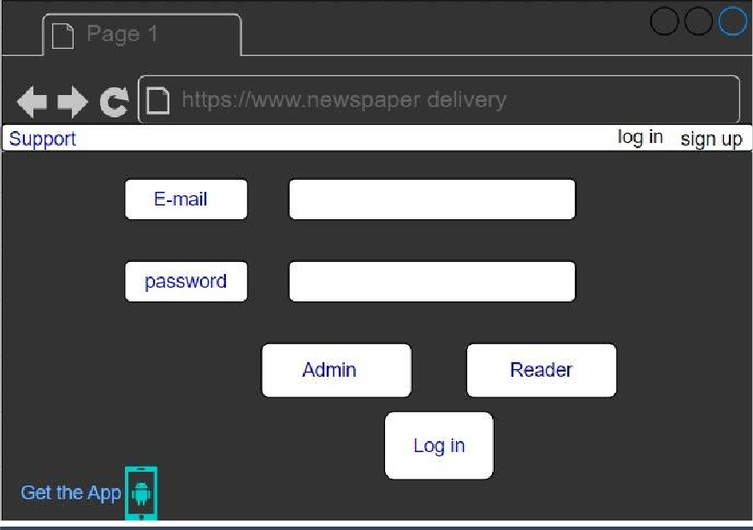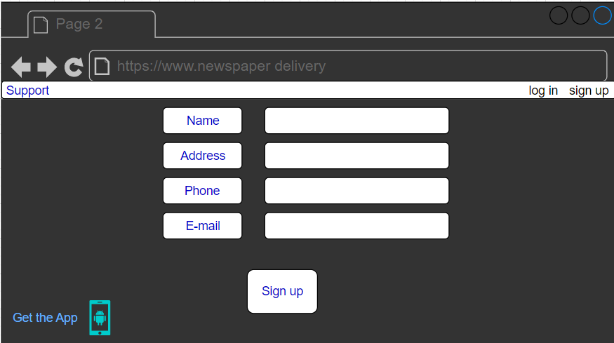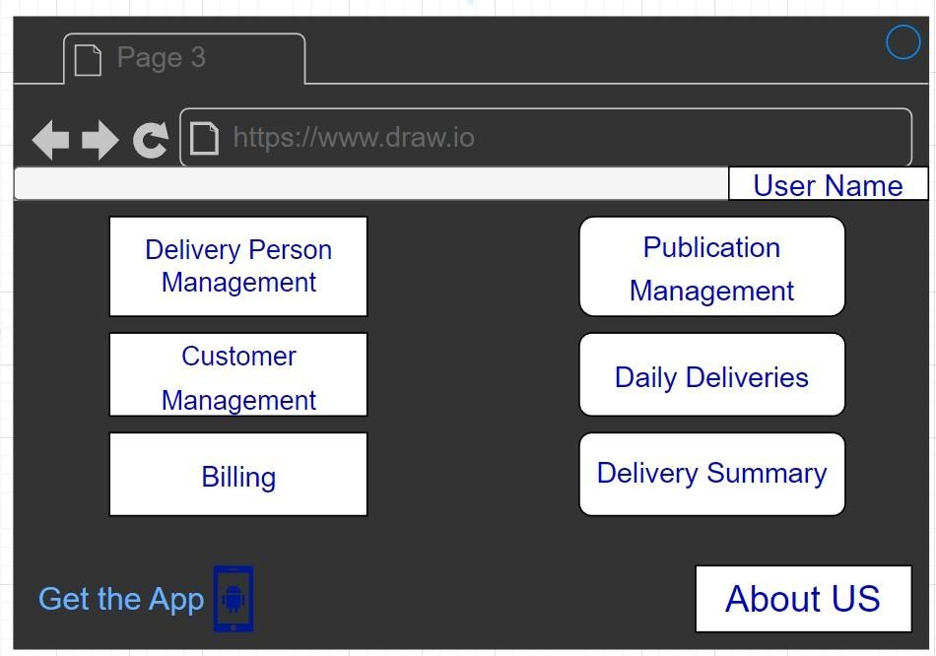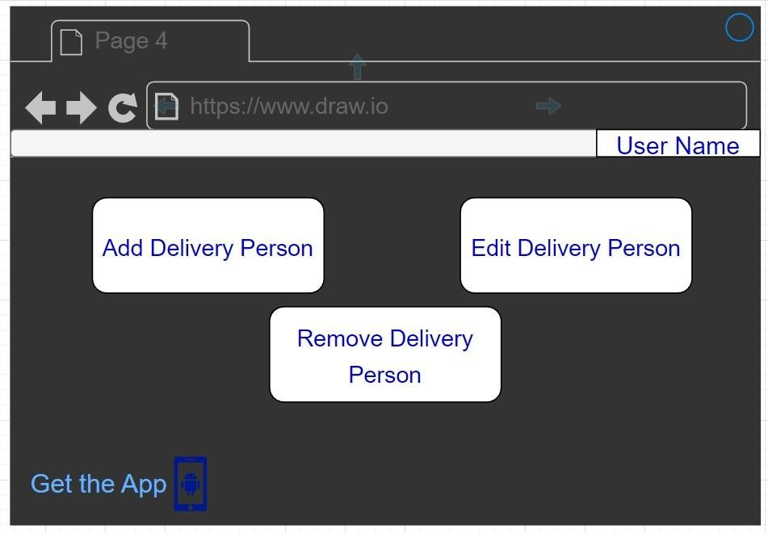

When you open the website you will see login screen.

If you have no account press on sign up at the top of the page

When you press on sign up the personal information page open where you will fill your personal details to create an account

Manage delivery persons and their assigned delivery areas

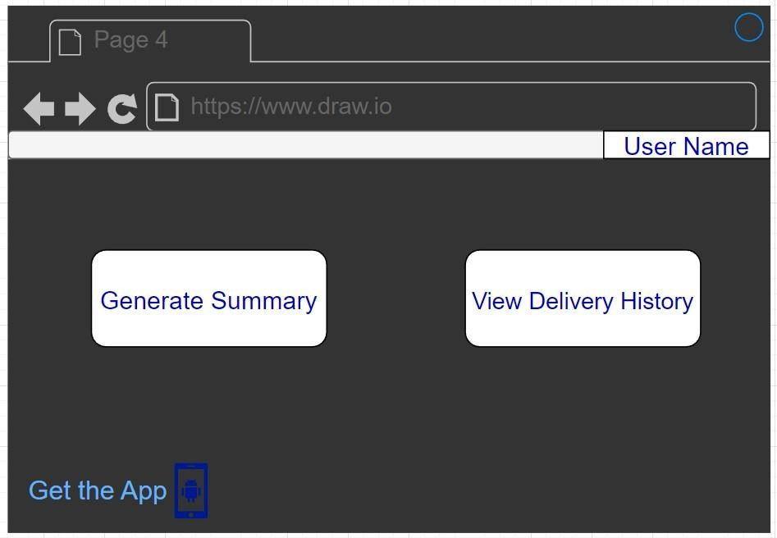

Choose the report type such as the summary of deliveries, customer details, and publication details.

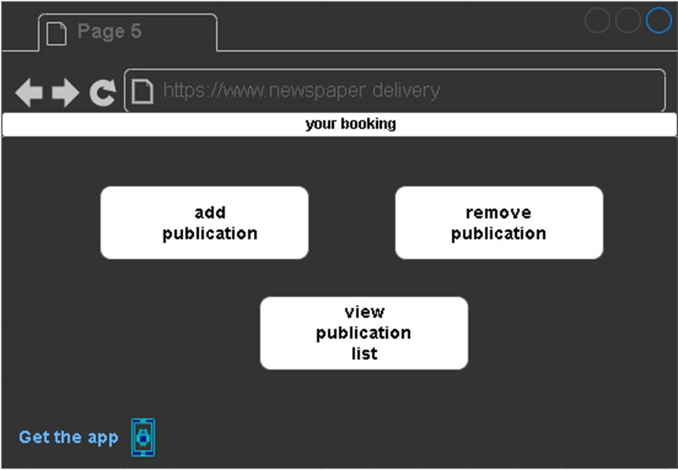

Click "Add Publication" to add a new publication or "Edit" to modify an existing one.

Enter publication details such as name, price, and delivery schedule.

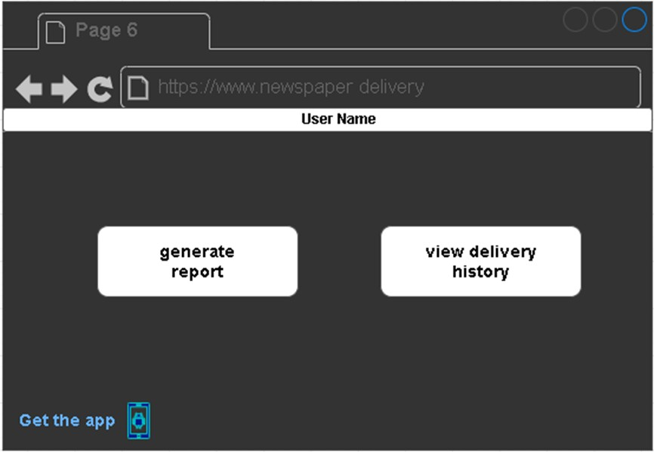

Choose the report type such as the summary of deliveries, customer details, and publication details.